Exercise 1: Setting Up Junit

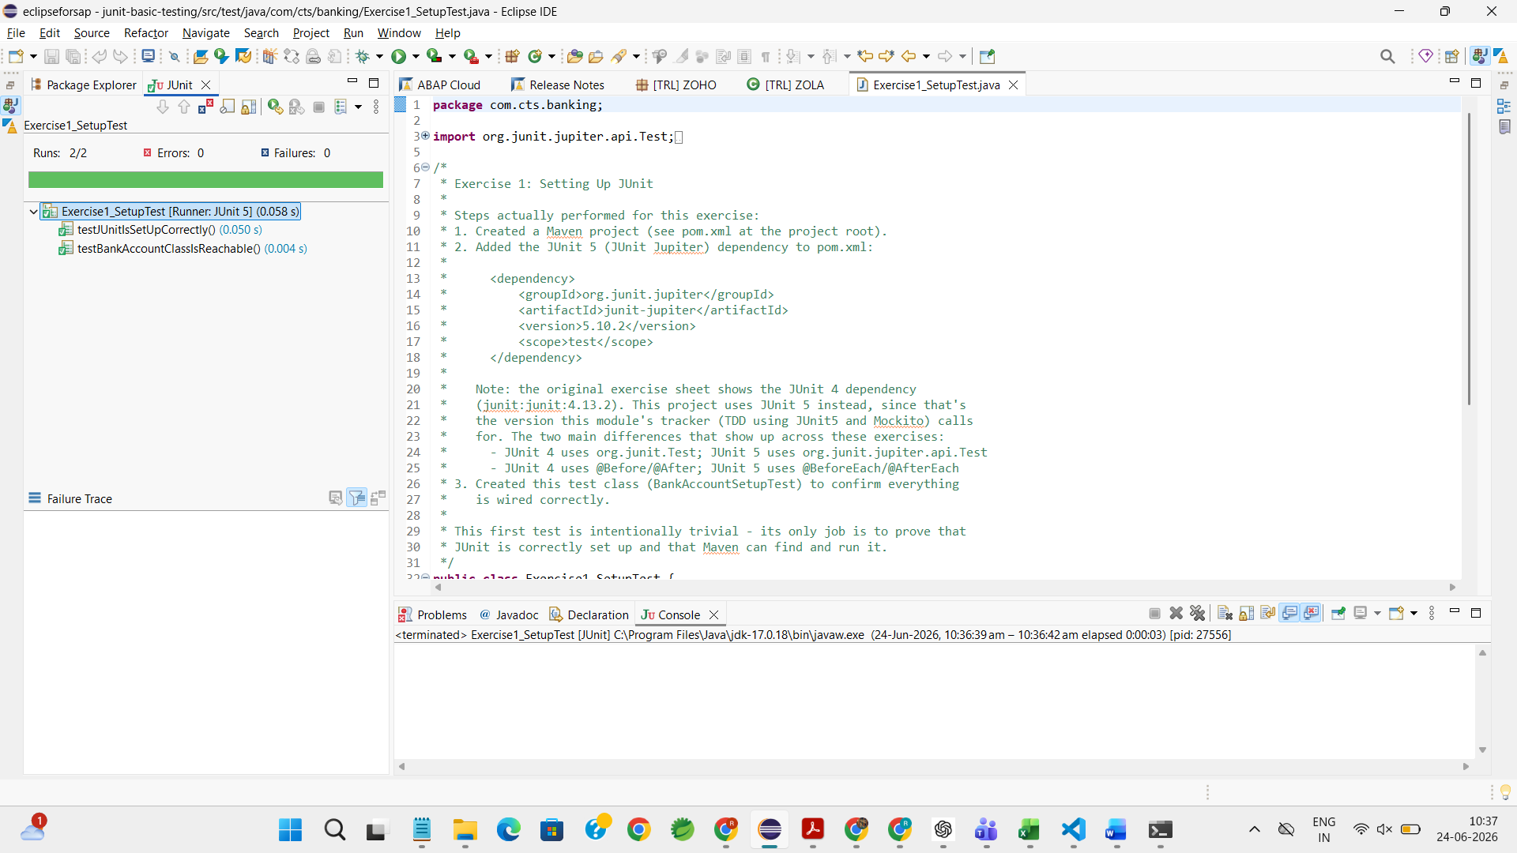

Exercise 3: Assertions in Junit

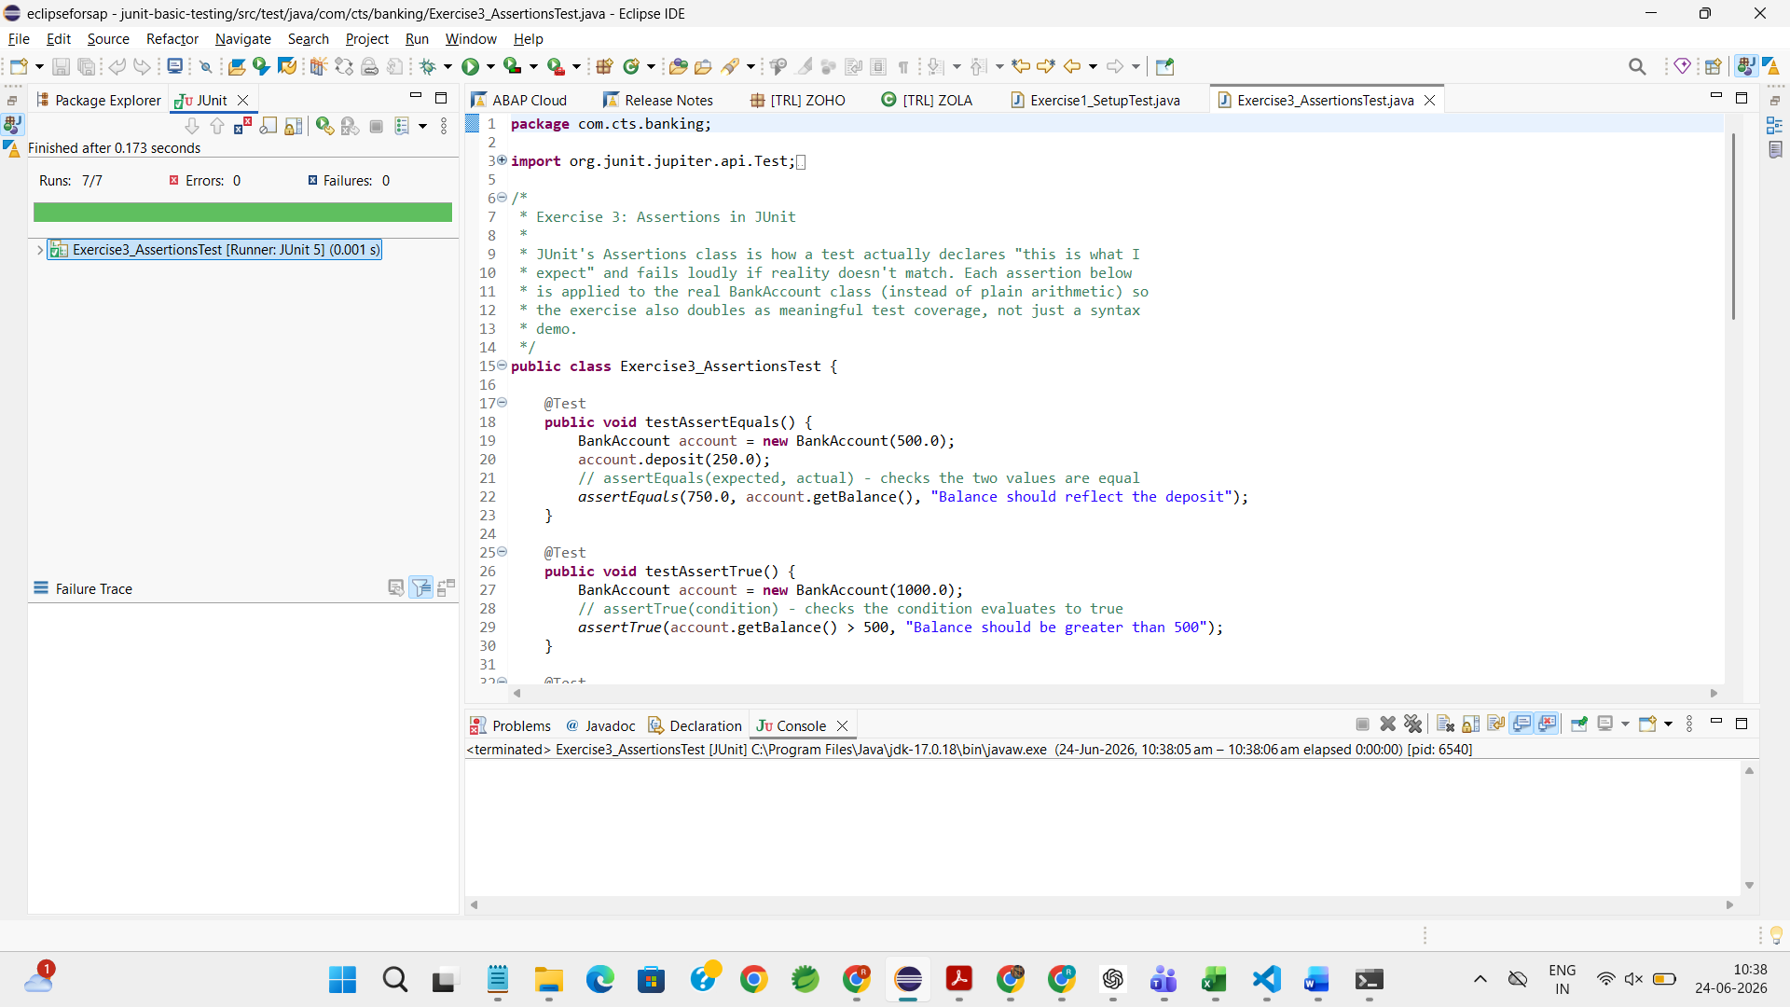
Exercise 4: Arrange-Act-Assert (AAA) Pattern, Test Fixtures, Setup and Teardown Methods

